Creating Your Elevator Pitch

ELEVATOR PITCH DEFINITION

An elevator pitch is an overview of an idea, product, service, project, or other solution and is designed to just get a conversation started.

Overview
The point of an elevator pitch isn’t to get into every detail of your Solution. Instead, all you want to do -- and all you have time to do -- is to make sure the audience understands what you are talking about and what’s in it for them.

Just Get a Conversation Started
One reason why so many people deliver completely ineffective elevator pitches is they don’t understand the purpose of an elevator pitch. They act like the purpose of an elevator pitch is to close the deal while in truth the purpose of an elevator pitch is to just interest the audience in continuing to talk.
THE PROBLEM
The problem is too few people are prepared to deal with such a situation. They haven’t considered what they would say, much less prepared something to say or rehearsed saying it.
As a result, instead of capitalizing on the opportunity, they just let it walk out the door.

THE SOLUTION
The goal of this session is to ensure that you know how to handle situations like the ones described above; that you know what to do, and what to say, if you have just a minute or two to catch the attention of the person with whom you most want to speak. This means developing an elevator pitch!

THE NINE C’S OF AN EFFECTIVE ELEVATOR PITCH

Now that you have a high-level sense of what an elevator pitch is, and what an elevator pitch is designed to do, let me drop down a level and discuss the characteristics of an effective elevator pitch.
After working with hundreds of business owners, and studying hundreds of effective and ineffective elevator pitches, we have found that an effective elevator pitch is nine things.
1. Concise
2. Clear
3. Compelling
4. Credible
5. Conceptual
6. Concrete
7. Customized
8. Consistent
9. Conversational

Let’s discuss each of The Nine C’s at length elsewhere, but in the interests of repetition -- and one of the themes of this session is that repetition is good -- PERFECT PRACTICE MAKES PERFECT!

1. Concise
An effective elevator pitch contains as few words as possible and to the point.

2. Clear
Rather than being filled with acronyms, MBA-speak, and ten-dollar words, an effective elevator pitch can be understood by your grandparents, your spouse, and your children.

3. Compelling
An effective elevator pitch explains the problem your Solution solves.

4. Credible
An effective elevator pitch explains why you are qualified to see the problem and to build your Solution.

5. Conceptual
An effective elevator pitch stays at a fairly high level and does not go into too much unnecessary detail.

6. Concrete
As much as is possible, an effective elevator pitch is also specific and tangible.

7. Customized
An effective elevator pitch addresses the specific interests and concerns of the audience.

8. Consistent
Every version of an effective elevator pitch conveys the same basic message.

9. Conversational
Rather than being to close the deal, the goal of an elevator pitch is to just set the hook; to start a conversation, or dialogue, with the audience.

The term "Elevator Pitch" began as a term used to describe a planned and rehearsed 60 second pitch you could give in the short time you would have when you meet someone on the 20th story of a high-rise building elevator and you have until ground floor to tell them of your company and get them to offer an opportunity or referral (60 seconds).

A powerful elevator pitch must include these components:
- Who your customer is
- Why they need your product, i.e., the pain you are solving.
- The name of your product (or web site)
- Your primary benefit to the customer, i.e., the compelling reason to buy, and
- Where you fit in the marketplace against the competition

It seems straight forward, but is harder than it looks. People often confuse benefit with differentiation and want to restate the “why?” when stating the compelling reason to buy.

NOTES:

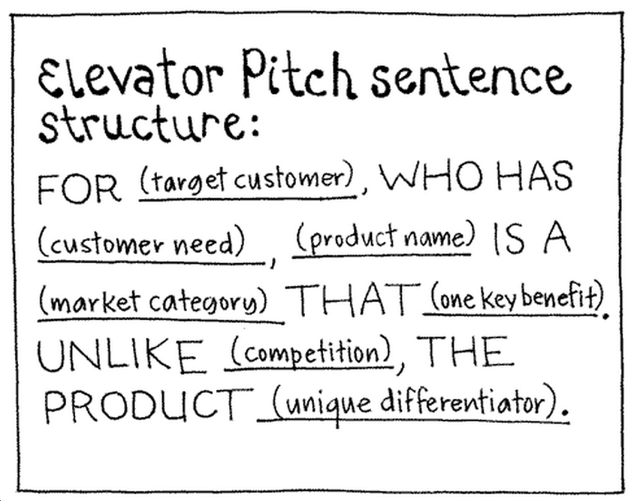

For (target customer)
Who (statement of the need or opportunity)
The (product name) is a (product category)
That (statement of key benefit – that is, compelling reason to buy)
Unlike (primary competitive advantage)
Our product (statement of primary differentiation).

EXERCISE:
Step 1 – Begin with an ACTION PHRASE that is NOT a noun. (”I am an X” — but don’t use a “label” in the blank. You don’t want people to put you in a box.)

Step 2 – Add a one sentence statement about what you DO. (”I do Y” — what do you help people or businesses do?)

Step 3 – Give a statement of the SPECIFIC IMPACT. (”People who utilize my process find Z” — list one or two things from the perspective of your potential employer.)

Step 4 – End with a CALL TO ACTION. (”I am looking to be introduced to…” — be specific! If you ask for something non-specific you are likely to get it. What good is that?)

Length
The perfect pitch should be no longer than 60 seconds, which is about 200-250 words. So imagine you are getting into the elevator at street level, deliver your pitch before you get off at the eighth floor.

NOTES:

EXAMPLE ELEVATOR PITCH
"Our company is called ConstructionBoots.com, an e-commerce website that sells brand-name construction boots. There are currently no companies serving this niche exclusively. ConstructionBoots.com will drive traffic to the site by linking to other websites catering to the construction industry as well as through word-of-mouth. In industry surveys, over 90% of construction workers have these three traits: 1) they have a favorite brand of boots, 2) they know their size, and 3) they hate shopping at stores. In our own polling, over 70% indicated that they would prefer to buy their boots online and have them delivered. Accordingly, we expect a great market response and rapid sales ramp-up.
We need $1.5 million in funding to get to the point where the company is self-sustaining. This should happen in the middle of our second year. Right now, we're seeking $500,000 of initial funding in exchange for a 30% ownership stake in the company. I am the CEO with lots of operational experience and deep contacts with boot manufacturers. Our Marketing Director was instrumental in the growth and recent sale of a very successful e-commerce clothing company. If we hit our numbers, we expect to be able to sell ConstructionBoots.com to a 'brick and mortar' retailer within 3 years."
----------------------------------------------------------------------------------------
Kernan Consulting is an awarding winning business consulting firm that specializes in Coaching, Advising and Mentoring small business owners of VAR’s, MSP’s and technology consulting companies. We successfully do this through our self-paced coaching programs, peer group coaching programs and one on one coaching programs.
What make us different is we focus on results and help our customer meet their goals: Our average customer will see an average of 77% increase in net profits within 12 months and outperform un-coached customers by 2.5x.
Unlike our competition, our coaches, methods and templates are all proven and successful. We implement these same techniques with our customers. Furthermore, our owner has a successful 25-year track record with the growth and sale of three companies of his own and has hundreds of success stories over the past 10+ years.
We combine specialized coaching with our creative industry intelligence that creates results unlike any other in the market. Whether it’s a custom engagement or group member, we help create the WOW factor with every project to ensure that our client’s products and services stand out amongst all their competition. Contact us for your free consultation today.

CLOSING

Don't forget that the goal of a successful elevator pitch is to prompt your recipient to ask you the all-important "tell me more."

FIREUP AND MAKE IT HAPPEN!!!!

EXERCISE

